DE LA SALLE UNIVERSITY
Dasmariñas, Cavite
Marketing Department

Services Marketing Plan
For
Las Casas Filipinas De Acuzar

Submitted By:
Joanne Mae Palad
Josephine Lomongo
Dyan Mendoza
Jennilyn Alzate
Glyns Ducot
Vince Cruz
Hace
Ace Vejeracion

Submitted To:
Ms. Evangeline Reyes
October 8, 2010

- Executive Summary
Family and relationships are very important to most Filipinos. A true Filipino, whether rich or poor, married or single, and young or old, values the essence of family and relationship bonds. Filipinos, in whatever status of life they maybe in, has a heart for their friends, parents, children, partners, business partners, wives, and other people around them. To give more weight to it, Filipino, also known as “Pinoy”, can even consider those not related to them by blood as their own family. That’s why most Filipinos observe the sanctity of different ceremonies such as weddings, baptismal, debuts, reunions, family outings, religious outings and business meetings or team buildings. This is because of the close family ties, hospitality and “pakikisama” built together with the Filipino cultural values and traditions.
Though not all Filipinos strictly observe cultures and traditions rooting from their forefathers, many still give value to relationships and different ceremonies like birthdays, Christmas, New Year, debuts, weddings and baptismal but with a semblance of a western style.
In this marketing plan, Las Casas Fiipinas De Acuzar will tap the innate value every Filipino has by offering different supplementary services showcased through different marketing and advertising concepts. The marketing team will lay down all the analyses and strategies needed together with a comprehensive budget and marketing plan. This paper will be backed up with the necessary collaterals for Las Casas Filipinas De Acuzar’s promotion and education plan.
- Situation Analysis
The analyses of Las Casas Filipinas De Acuzar according to its company, competitors and customers/ market’s current situation are stated briefly in this marketing plan.
  - Company Analysis
Las Casas Filipinas De Acuzar is a heritage hotel formerly known as Casa Real De Acuzar that is owned and managed by the Genesis Hotels and Resorts Corporation. It had its grand opening last February 2010. After the owner, Mr. Jerry Acuzar was able to remake 21 old mansions and stone houses as his hobby for a decade, Genesis Hotels and Resorts Corp. was soon able to open Las Casas Filipinas de Acuzar Heritage Hotel early this year. Las Casas Filipinas de Acuzar is still in its soft opening until now since some of the facilities like spa, gym and bridge connecting the resort to the beach, are still under construction.
Las Casas Filipinas de Acuzar is a hotel and resort with a 19th century setting and is a 3-hour drive away from Metro Manila.
Las Casas is currently continuing its operation by accepting room reservations for family or group outings. The hotel and resort is also a great place to shoot a 19th century movie and pre-nuptials because of its dramatic cobblestone filled walkways, parks and structures. Las Casas Filipinas De Acuzar is also currently known for its remarkably rebuilt mansions, stone houses and Indio stilt houses that are mostly the focus of many Filipino bloggers who were able to experience and behold its beauty.
Aside from the historical buildings, structures and the 19th century setup, Las Casas hasn’t clearly laid down the whole picture of what more can be experienced from Las Casa Filipinas De Acuzar Hotel and Resort.
  - Competitor Analysis
Las Casas currently competes in the local industry of hotels and resorts and it is being compared by most to Intramuros and Vigan.
Intramuros, is a walled city multifaceted by the Spaniards upon their colony of Manila and is located along the southern bank of the Pasig River and was built by the Spaniards in the 16th century and is the oldest district of the city of Manila, the capital of the Philippines. The name is taken from the Latin, intra muros, literally "Within the walls", meaning within the wall enclosure of the city/fortress, also describes its structure as it is surrounded by thick, high walls and moats. During the Spanish colonial period, Intramuros was considered Manila itself.
It is constructed almost completely of stone blocks and possesses the same architectural traits one can see in other Spanish defenses like the Caribbean. It has been attractively landscaped with abundant tropical flowers and plants, and it is a relief for many families looking for shade in ever hot and muggy Manila. One can walk around the paths or use the pleasingly decorated horse drawn carriages. Some of the features of this park are old gunpowder rooms used as recently as World War II, seminaries and chapels, the Manila cathedral and museums. Intramuros is a gigantic area neighboring the Rizal Park where tourists can hire professional tourists guide for an educational trip. Here’s an image showing the Manila Cathedral and one of the historic buildings found in Intramuros. Also featured is a locally known means of transportation, the “Calesa”.
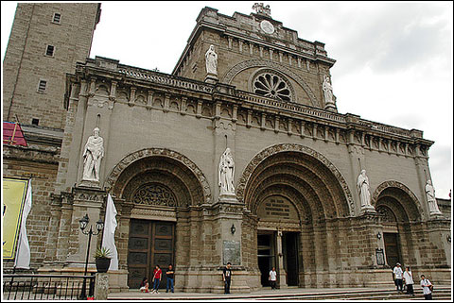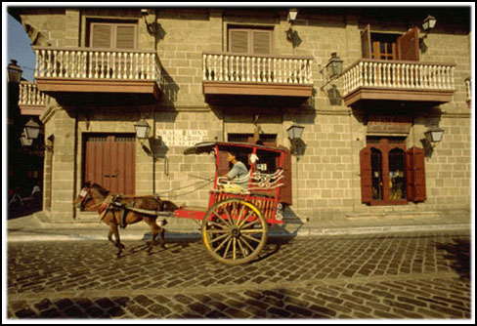
Figure 1. Intramuros
Aside from Intramuros, Vigan city is also one of the main competitors of Las Casas. It is found in Ilocos Sur. Established in the 16th century, Vigan is the best-preserved example of a planned Spanish colonial town in Asia. Its architecture reflects the coming together of cultural elements from elsewhere in the Philippines, from China and from Europe, resulting in a culture and townscape that have no parallel anywhere in East and South-East Asia. Vigan is the oldest surviving Spanish colonial city in the Philippines. The name Vigan was derived from "Biga", a giant taro plant that grows abundantly along the banks of the Mestizo River. Images shown below are the Vigan church and historic street surrounded with antique houses inside Vigan City.
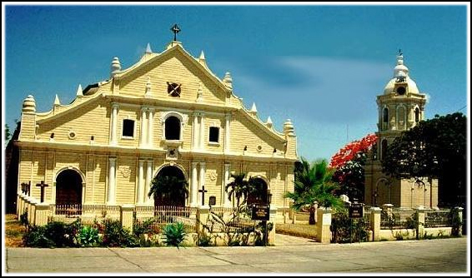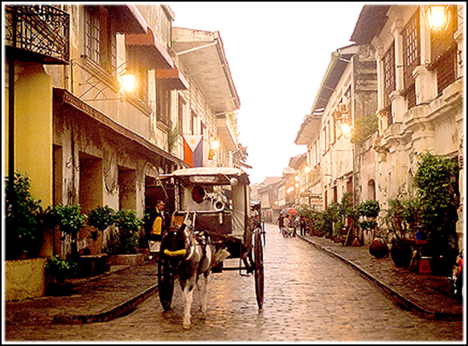
Figure 2. Vigan City
These two historic places can be considered as fully commercialized tourists spots because of the time that has passed. Intramuros and Vigan is not just well advertised and known locally and internationally but also supported by local government agencies for tourism purposes. Many establishments can now be found within the vicinities of Intramuros and Vigan like offices and the like.
  - Customer Analysis
The major customers of Las Casas Filipinas De Acuzar are composed mainly of families, barkadas, and other religious group who want to spend their time in a serene and relaxing place while beholding the unique historic setup found in the vicinity of Las Casas. Student exposure trips are also one of the target markets of Las Casas. Photographers and film makers go to Las Casas Filipinas De Acuzar as well. Las Casas’ customer analysis will be further discussed in the market summarization.
- Market Summary
Las Casas Filipinas De Acuzar currently targets the local market of the hotel and resort industry. The summary of the local market will be defined by its demographics, geographic descriptions, behaviors and trends.
  - Target Market
The current target and potential market of Las Casas Filipinas De Acuzar are tourist and vacationers from the Philippines. This potential local tourists and guests are composed of families, students, professionals, retirees and corporate groups wanting to behold the scenic beauty found inside Las Casas Filipinas De Acuzar.
The Philippines is a country in Southeast Asia in the western Pacific Ocean. Its location is on the Pacific Ring of Fire and its tropical climate makes it prone to earthquakes and typhoons. The country is also endowed with natural resources and is one of the richest areas of biodiversity in the world. The Philippines is an archipelago comprising of 7,107 islands, and is categorized broadly into three main geographical divisions: Luzon, Visayas, and Mindanao. The capital city of the Philippines is Manila, found in the National capital Region.
  - Market Demographic
By 2009, the Philippines have become the world's 12th most populous nation, with a population of over 92 million. It is estimated that half of the population resides on the island of Luzon. Manila, the capital city, is the eleventh most populous metropolitan area in the world. The population of the Greater Manila Area is around 20 million.
The population growth rate between the years 1995 to 2000 was 3.21% but has decreased to an estimated 1.95% for the 2005 to 2010 period. The median age is 22.7 years with 60.9% of the population aged from 15 to 64 years old. Life expectancy at birth is 71.38 years, 74.45 years for females and 68.45 years for males. (NSO, 2009)
Table 1
Top Ten Largest Cities in the Philippines.
Leading Population Centers
Rank | City | Population | Pop. Growth Rate | Region
1 | Quezon City | 2,679,450 | 2.53% | National Capital Region
2 | Manila | 1,660,714 | 0.03% | National Capital Region
3 | Caloocan | 1,378,856 | 2.53% | National Capital Region
4 | Davao City | 1,363,337 | 1.81% | Davao Region
5 | Cebu City | 798,809 | 2.16% | Central Visayas
6 | Zamboanga City | 774,407 | 1.43% | Zamboanga Peninsula
7 | Antipolo | 633,971 | 5.22% | CALABARZON
8 | Pasig | 617,301 | 2.29% | National Capital Region
9 | Taguig | 613,343 | 4.07% | National Capital Region
10 | Valenzuela | 568,928 | 2.23% | National Capital Region

  - Market Geographic
The Philippines is an archipelago of 7,107 islands with a total land area of 300,000 km² including inland bodies of water. The 11 largest islands contain 94% of the total land area. The largest of these islands is Luzon at about 105,000 km². The next largest island is Mindanao at about 95,000 km². The archipelago is around 800 km from the Asian main land and is located between Taiwan and Borneo.
The Philippines is divided into 17 regions with all provinces grouped into one of 16 regions for administrative convenience. The National Capital Region however, is divided into four special districts.
Most government offices establish regional offices to serve the constituent provinces. The regions themselves do not possess a separate local government, with the exception of the Autonomous Region in Muslim Mindanao.
Table 2
The Philippine Regions
- Ilocos Region (Region I)  - Cagayan Valley (Region II)  - Central Luzon (Region III)  - CALABARZON (Region IV-A)  - MIMAROPA (Region IV-B)  - Bicol Region (Region V)  - Western Visayas (Region VI)  - Central Visayas (Region VII)  - Eastern Visayas (Region VIII) | - Zamboanga Peninsula (Region IX)  - Northern Mindanao (Region X)  - Davao Region (Region XI)  - Soccsksargen (Region XII)  - Caraga (Region XIII)  - Autonomous Region in Muslim Mindanao (ARMM)  - Cordillera Administrative Region (CAR)  - National Capital Region (NCR; Metro Manila)

  - Market Behavior
Behavior of Las Casas’ target market is predictable especially when it comes to their buying and purchasing patterns. Most Filipinos are cost and quality conscious because of the economical crisis everyone is affected and aware about.
Another behavior observed in the target markets are the values and customs they continue from generations to generations. Family ties are still given high importance and consideration even in purchasing habits or patterns. Each also observes respect, pagkakapatiran at pagdadamayan. Paying respect is important to the target market. Hospitality is also one of the common values observed in the Filipino market. Most of them are meticulous about entertaining guests and serving others.
These are the behaviors observed in the market currently targeted by the local hotel and resort companies in the Philippines.
  - Market Trends
The Philippines is a country filled with people with different traditions and values but most locals give value and celebrate different occasions with families and friends, from the lightest to the grandest of them. Filipinos celebrate occasions on places like resorts, hotels and other tourist spots to give their special events color and meaning. Location plays an important role in celebrating different Filipino occasions.
The hotel and resorts industry adds a sentimental meaning to the gatherings Filipinos have with the presence of their loved ones. Because of these, many hotels and resorts in the Philippines offer events packages to cater these market needs. A hotel and resort package usually includes catering, photo and video coverage and location setup to make the event management easy for the target market. The market, also, usually goes for what is convenient and cost-effective at the same time.
Other trends in the hotel industry are the green architecture of hotels which amplifies environmental issues as one of the biggest issues in the travel industry today. It is a common experience now to find a note in a hotel room saying that towels are not changed every day to conserve precious water. Many hotels install flow restrictors in shower heads and aerators for faucets.
Ecologically-conscious hotels have adopted other measures to ensure sustainability in the earth’s resources. Some have recycling bins inside hotel rooms. Housekeeping staff members are enjoined to use nontoxic cleaners and detergents. They select suppliers who have high environmental standards. Even the coffee in hotel room mini bars is organically and shade-grown.
Hotel stationery and writing pads in many hotel rooms are made of recycled paper, and the management is pleased to inform guests about that. Paperless check-in and check-out is being encouraged as many procedures can be done electronically.
The hospitality industry has taken on an environmentally-responsive culture. Hotel guests are shown that simple steps have a positive impact on the environment.
On the other hand, energy is conserved by the key card system which automatically shuts down lights and air-conditioning when the guest leaves the room. Compact fluorescent lamps are almost in full use in most hotels.
Green design and proper building orientation are key factors that influence energy efficiency and comfort of hotel guests. Some hotels abroad now offer eco-transportation and hybrid cars to transport guests to nearby places. They also have donation programs and give amenity bottles and tin cans and old newspapers to local charities.
Wall-to-wall carpets and heavy drapery are dust collectors, and eco-friendly hotels pamper their guests with healthier furnishings.
Using locally sourced building materials for hotel construction is a green practice and saves on embodied energy.
Cutting down a forest to build a resort destroys the ecosystem and has a negative impact on animals, air, water and future vegetation. Putting up a hotel in the middle of a forest is not ecologically-sound.
Wastewater treatment and management of chemical and toxic substance disposal are big concerns in the hospitality business today.
It is also a trend that hotels that reflect the local culture and spirit of the place are green hotels because they preserve the culture of the place and people. In Bali, Indonesia, a famous resort spa involves the local community by hiring workers to maintain the traditional art work and craftsmanship used in the villas and interior furnishings.
Implementing environmental programs have been proven to boost the bottom line.
Resort trends however, include cabins or cottages beside the beach or pool. Vacationers still yearn for lazy days in a cabin beside the beach. Full kitchens, stylish furnishings, whirlpools, DVD players and high-speed internet connections have joined the amenities that should be included with the once laid-back family retreats. Families want to get away from it all, but not from conveniences. Guests also want plenty of space and comfort. They're reconnecting with family and friends in huge "reunion cabins" like villas available for group guests and families.
Spa and gym is also one of the trends in local or international resorts for the guests to be able to distress. Massages and facials are just the beginning, and the treatments are not just for women. Men and couples now also indulge in full-body wraps and massages.
These days also, amenities available for kids are needed in a resort such as kiddie pool, kiddie slides, play ground and other accessories needed for children. Through these, parents won't have to worry about entertaining active kids at family-oriented resorts. Giant indoor water parks are multiplying at least as fast as spas, with slides that hurtle daredevils down several stories, buckets that dump hundreds of gallons, tree houses, pirate ships and surf pools. Kids' programs are expanding, too, with options such as "dive-in" poolside or evening movies.
These current hotel and resort trends should be considered by new entrants and booming companies in the travel and tourism industry.
  - SWOT Analysis
The company strengths and weaknesses and the local and international opportunities and threats currently encountered by Las Casas Fiipinas De Acuzar are briefly discussed in this area.
      - Strength
Las Casas Filipinas De Acuzar has the following strengths that give this 19th century hotel and resorts an edge over competitors, giving it at the same time, a potential to out beat the currently booming hotels and resorts companies in the country.
- Las Casas Filipinas de Acuzar has a historical value in the Philippine heritage and culture as a prime spot for Filipino art and craft
- The ambience of La Casas Filipinas de Acuzar is the perfect blend of luxury and comfort while rediscovering your roots
- Hotel with a resort feature in one.
- Fresh and new rooms and amenities
- Accessibility – 3 hours travel from manila
- Unique Hotel settings
- Weaknesses
Flaws and failures in products, services features and other marketing mix or 8 P’s strategies in Las Casas Filipinas De Acuzar are briefly discussed below. This is to help the newly opened 19th century hotel and resort determine what should be improved and developed.
- Lacks offered supplementary services
- Low promotion or advertisements
- Not easily accessible; transportation for private vehicles only, no direct route for public vehicles
- Under developed beach
- Undeveloped amenities such as spa and gym
- Website updates and information are inconsistent and not fully observed inside the resort
- Low target market awareness on offered services
- Lack of facilities available at night/ limited space in bars and other amenities
- Lack of presence in the internet
- Opportunities
Local and international opportunities that can be entered into and pursued by the company are the following:
- Expand target market to catering special events
- Adapting new trends in the travel industry
- Foreign travelers through entering global travel industry
- Partnership with local travel agency – affordable and convenient for transportation or trip to Bagac
- Corporate and non-corporate accounts for meetings and outings
- Threats
Local threats that might affect the company’s current and future marketing strategies are stated below. The following should be well analyzed and considered by the company upon the creation of their strategies.
- The hotel and resort industry is huge and trends are costly and demanding
- Aggressive new entrants in the local travel industry
- Local travel security and safety threats and controversies
- Booming and upscale local hotels and resorts (e.g. Boracay, Shangri-La)
- Known international hotels within the country
- Alternative for special events location such as public resorts
- Comprehensive Analysis (Company's Current 8P's)
A comprehensive analysis of Las Casas Filipinas De Acuzar’s current core and supplementary product offers, pricing strategy, distribution strategy, promotion strategy, people, physical environment, process, and productivity and quality is extensively stated in this part of the paper.
      - Product Element
The core product of Las Casas Filipinas De Acuzar highly involves the participation of guests and visitors. Hence, Las Casas Filipinas De Acuzar offers services that falls under the category of people processing where customers/ visitors and guests encounters play an important role.
As part of their core product, Las Casas Filipinas De Acuzar has 17 air conditioned guest rooms in Paseo de la Escolta hotel that is classified into three; Studio Deluxe, studio suite with loft, and executive suites. The total number of rooms available in each category are as follows; 5, 8, and 3 respectively. These rooms are already fully furnished for overnight or consecutive lodging and accommodations.
Las Casas Filipinas de Acuzar also offers houses that are replicas of the 18th and 19th century, Casa Binondo I, Casa Binondo II and Casa Meycauayan.
Casa Binondo I is a four bedroom house that can accommodate no less than eight persons. In the first floor of the house lies a room that has a king size bed and has its own toilet and bath. A spacious room with a queen size bed is placed up in the second floor. This room has its own toilet and bath and with access to the balcony. Two other rooms are placed on the second floor of the house, these two rooms has one queen size bed each and adjacent toilet and bath that the guest may share. Casa Binondo I is filled with Noveau art and furniture that brings the guests back to past.
Casa Binondo II house has three bedrooms; a large bedroom is cited in the first floor with one king size bed, toilet and bath of its own. Two regular sized bedrooms with queen sized beds each room is located on the second floor of the house, these rooms shares an adjoining toilet and bath. An over looking Azotea or balcony is also found on the second floor.
The biggest house among the three is the Casa Meycauan, this is a five-bedroom house that can provide accommodation for ten. Two spacious bedrooms that have one king sized bed each and with individual toilet, bath and shower is placed on the first floor of the house. On the second floor lays three bedrooms two of which has twin beds and individual toilet, bathtub and shower. The other remaining room is a regular sized room that holds one queen sized bed with individual toilet, bathtub and shower. Just like the two other houses, Casa Meycauan has a cover overlooking Azotea or balcony.
The houses have facilitating features such as air conditioned rooms, hot and cold showers, living areas, and dining facilities. The rooms in Paseo de la Escolta as well as the rooms in the villas are designed to give the guest the experience of living in the past without the impossibility of leaving the present. These are the core products of Las Casas Filipinas De Acuzar. A flow chart of Las Casas’ service delivery that would show the core and supplementary services currently offered by Las Casas Filipinas De Acuzar is shown in the smart chart below.
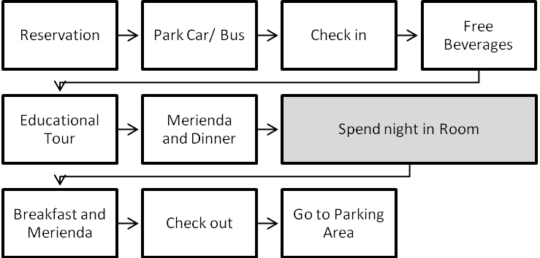
Figure 3
Las Casas’ Core and Supplementary Delivery Process
After guests reserve for a specific date, time and room, guest arrives and use the parking lot for their means of transport. Front liners offer free drinks to guests and tourists during arrival. Next step guests do is to check in. Aside from that, a tour around the place is given by a well-educated tourist guide. After that, Merienda is served 3:00pm in the afternoon and Dinner, 8:00pm at night on the dining area. The guests then spend the night at the hotel room. The breakfast is served at 7:00am and morning merienda, 10:00am. Guests can then check out by 11:00am and wake the walk to the parking area for theit rides. These are part of the core, facilitating and enhancing services offered by Las Casas Filipinas De Acuzar.
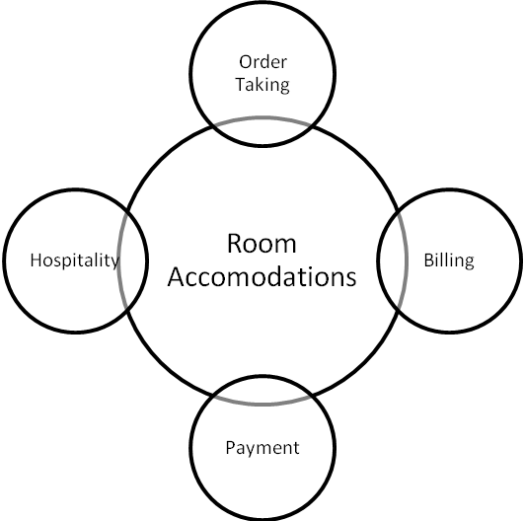
Figure 4
Las Casas’ Flower of Service
As for Las Casas’ flower of service, the current supplementary services offered by Las Casas are order taking, billing, payment and hospitality. Other parts of the service flower are not yet fully observed. The illustration can be seen in the figure shown above.
Las Casas Filipinas De Acuzar offers order taking services to facilitate the reservation of rooms, amenities and facilities in Las Casas. Afterwards, a bill or verbal and written statement of the amount due upon reservation is given to the guest or client. Las Casas then, gives few options to the guest on how to make the payment. Lastly, upon arrival of the guests and visitors, staffs or front liners greet and offer beverages to the former. Toilets and washroom are also available in almost all structures. Securities are available in the area as well. These four supplementary services can be observed as the services currently offered by Las Casas Filipinas De Acuzar.
Aside from the supplementary products that the hotel offers, there are also different amenities and facilities found within the hotel and resort. They have food and beverage outlets; the Marivent Café where Filipino-Hispanic cusine are offered and served the traditional way and the Taberna del Señor Pepe where variety of Spanish tapas, deli items, cocktails and cigars are available. El Museo or “the museum” can also be found inside the hotel where in artifacts and items from the past can be seen.
Las Casas Filipinas De Acuzar offers different function rooms and one of them is called the Candaba House that is originally built in 1780, this house can accommodate 20-200 person. The Baluiag House 2 can provide accommodation functions for 30-80 people while the Instituto de las Bellas Artes has function rooms for small groups of up to 40 people. The highlight of this house is the wide ballroom that is available for use. La Plaza Mayor and El Centro serve as the resort's outdoor social activity centers. Both areas may be used for receptions and events and can accommodate 500-1,200 persons.
Other plans not yet fully constructed inside the resort are the Marahai spa which should be located at the wooden Indio stilt houses near the beach and the El Gimnasio or the physical fitness gym. Marahai spa, as proposed, should offer an experience of the traditional hilot that uses complete herbs to provide a very relaxing experience. The service will be provided by highly trained staff to assure quality of service. Just right outside the Indio houses, La Pistina or the swimming pool can be found. This place offers a perfect vies of the Umagol River Rippling to the South China Sea. El Gimnasio or The Gym enables guests to have their vacation without having to skip their physical fitness routine. The Hotel also provides a game room the Salon de Juego. A church is also being planned to be built across La Pistina after the bridge which, is also currently under construction.
As part of the hotel’s hospitality, the management performs supporting services like different activities such as Day Tours, Educational Tours, Culinary Tour, Traditional Games (i.e. Tumbang Preso, Patintero, Palo Sebo), Basket/Hat Weaving, Rice Planting, Tomato and Vegetable Planting, Zarsuela, Cultural Dances, Harana, Carabao Rides and Cigar Rolling. The guest can join any of these activities to enjoy and occupy their empty hours.
      - Prices and Other Consumer Outlays
Las Casas Filipinas De Acuzar offers affordable pricing. For the rooms in Paseo de la Esccolta Hotel, the studio deluxe rooms costs Php3, 825.00 net per night, each room of this type has a queen size bed, and individual toilet, bathtub and shower that can accommodate no less than 2 adults and two children.
Paseo de la Escolta hotel also holds 8 studio suites. Six units of these suites have two queen size beds, one bed is placed in the loft and the other is placed below. One unit has only one king size bed and the remaining room has one queen size bed and one single bed. All of the units have their own toilet, bathtub and shower. These rooms can accommodate two adults and two children and costs Php5, 525.00 per night.
On the other hand, their Executive Suites costs Php7, 225.00 per night, this room can provide accommodation for four adults and two children. This room has three floors; the first floor serves as the receiving area where toilet and bath is placed. In the second floor a queen sized bed and an individual toilet and bathtub and shower can be enjoyed by the guests and two queen size beds are placed on the third floor. This room can hold four adults and two children. Each room in Paseo de la Escolta has a modern bath with hot and cold showers, a 21" flat screen TV and DVD player.
Casa Binondo I, however, is available for occupancy at Php20, 000.00 per night and Casa Binondo II, which can accommodate six persons, Php15, 000.00 per night.
The biggest house among the three is the Casa Meycauan, this is a five-bedroom house that can provide accommodation for ten persons and costs Php25, 000.00 per night.
      - Place and Distribution of Service
The place and distribution of service can be acquired inside the hotel itself. Las Casas is located at Bo Pag-asa, Bagac, Bataan. Its sales office is located at Mezzanine Floor Victoria Towers, Timog Avenue, Quezon City that interested guests and clients may reach through emails and telephone lines. The management also tied up with organizations like universities to encourage visits. Below is a map to Las Casas Filipinas De Acuzar via SCTEX and NLEX Exits.
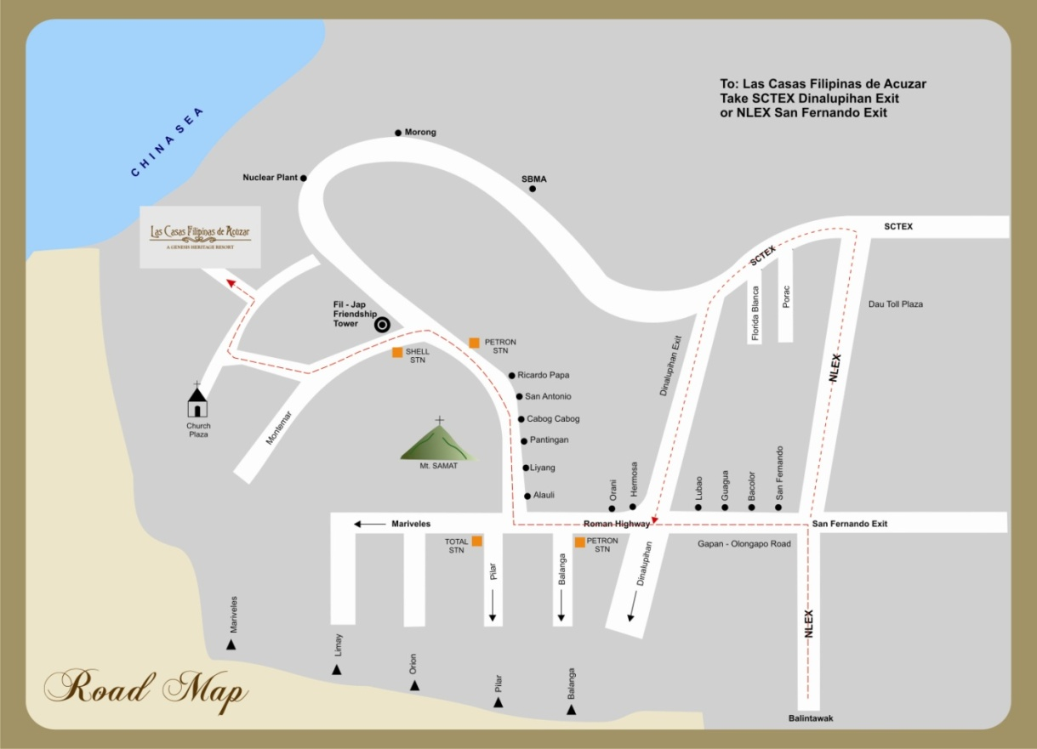
Figure 3
Road Map to Las Casas Filipinas De Acuzar
      - Promotion
As a promotion of Las Casas Filipinas de Acuzar, they are offering their studio deluxe room for Php3, 825 net per night. This room measures 44sq. meters and can accommodate 2 adults and 2 kids. Their 66 sq. meter studio deluxe with loft are offered for Php7, 225 that is suitable for 2 adults and 2 kids is also available for their promotion as well as their executive suite as big as 120 sq. meters that can accommodate 4 adults and 2 kids is available for only PhP7,225 net per night. A set breakfast at the Marivent Café for 2 persons in a Studio and 4 persons in Executive Suites is included in every package. In addition guest are privileged the use of Swimming Pool and Beach Area and are entitled for a Guided Heritage Tour. All Taxes and Service Charge are already included in the promotion amount.
For a group of ten persons or above who would like to avail of day tour in the hotel, they have two different day tour packages to choose from. Package 1 costs Php1, 000per person, this includes 1 set lunch, a welcome drink, 30 Minutes to 1 Hour Guided Tour of the Heritage Houses, Entrance Fee and Use of Beach Area,1 Lunch, Afternoon Snack, 2 Tetra-packed Juices, 2 Bottles of Mineral Water, a Vicinity Map, and all taxes and service charge are already covered. This promo is available for grouips with minimum of ten persons. Their package 2 costs PhP 1,200 net per person. Everything is pretty much the same with package number one except the buffet meal in package 2 instead of a set meal in that of package 1.Guest can opt to have a buffet ihaw-ihaw or buffet barbeque, an additional of 500 pesos is required to avail this extra service.
A live-out meeting package which allows guests an eight hour use of their exclusive function rooms is also available. This would cost each guest Php1, 200 and Php1,500 depending on their choice package, a set or buffet package. Welcome drinks 1 morning snack, 1 Lunch, 1 afternoon snack, free flowing coffee / tea and mint candied are included in the package. The management will also provide Conference pads and pencils, Whiteboard, Flipchart with markers that the guest may use. All Taxes and Service charge is already covered.
      - Process
Las Casas follows a standard process in entertaining prospect clients and guests but, the processes involved in these procedures are not clearly stated, thus, the marketers are only basing on the observed service process given by Las Casas. The current service process of Las Casas will be described by its service flowchart.
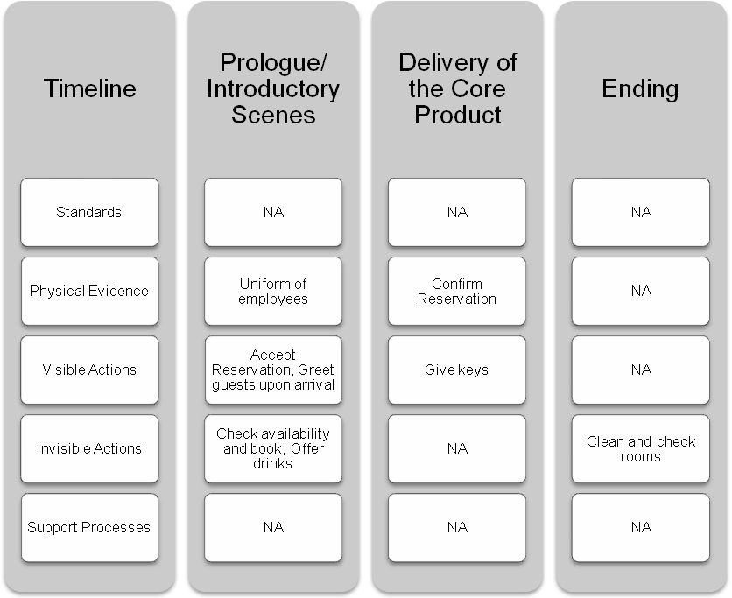
Figure 4
Las Casas Service Process
- Marketing Strategy
Las Casas Filipinas De Acuzar is focused on creating one of a kind strategies that will help the company achieve its long term marketing and financial objectives. The company mission, marketing objectives, financial objectives, target marketing strategy and positioning strategy will be clearly defined in this are with a comprehensive statement of the proposed marketing mix for the years 2011 to 2013.
      - Mission
Las Casas Filipinas De Acuzar is committed in thoroughly understanding the needs of its guests and associates, to consistently surpass their expectations by delivering personal and intuitive services.
Las Casas Filipinas De Acuzar is committed to provide maximum customer satisfaction through providing alert, competent and personalized service, assuring wholesome and safe accommodation, enhancing cooperation and teamwork in the organization and ensuring employee's welfare and development while working towards a globally competitive service.
      - Marketing Objectives
Las Casas Filipinas De Acuzar has the following objectives that it targets to achieve by the end of the years 2011 to 2013.
    - To be able to open the spa and beach resorts at the mid of the year 2011.
    - To be known and recognized in the local tourism industry before the end of the year 2011.
    - To increase target market’s service and brand awareness by 50 % at the end of the year 2011
    - Increase visitors by 40% in 2011
      - Financial Objectives
- Achieve revenue growth of 10% per year
- Boost annual returns on invested capital from 15% to 20%
- Stronger bond and credit ratings
- Recognition as the best cultural heritage hotel and resort in Philippines
- A more diversified revenue base
- Stable earnings during recessionary periods
      - Target Marketing
Las Casas Filipinas De Acuzar can be located at Region 3 which is also known as the Central Luzon Region. Central Luzon, where Bagac, Bataan can be found, is surrounded by most of the big cities in the Philippines (see Table 1) that’s why the management sees the potential target market to arrive firsthand from Regions 4a, NCR and including Region 3.
In central Luzon there are two possible cities that can be major potential markets, Angeles city and Olongapo City. Promotion, advertising and education strategy will target these cities.
Aside from the Central Luzon Region, Region 4a or Calabarzon will also be considered as a major potential market. Cities from Cavite and Laguna will be reached through advertisements and educational promotion. The region is composed of five provinces, namely: CAvite, Laguna, Batangas, Rizal, and Quezon; the region's name is formed from the names of these provinces.
The region is located in southwestern Luzon, just south and east of Metro Manila and is the second most densely populated region. Calabarzon region is in the southern part of the main island Luzon. It is easily accessible from and is a popular destination for Filipino families living in manila.
Likewise, NCR or the National Capital Region, which is the smallest yet the busiest city in the Philippines, will have the largest advertising and promotional efforts to be able to reach the corporate, families and professional markets Las Casas will target. Metro Manila is the most populous of the twelve defined metropolitan areas in the Philippines. As of the 2007 census, it had a population of 11,553,427, comprising 13% of the national population. Including suburbs in the adjacent provinces (Bulacan, Cavite, Laguna, and Rizal) of Greater Manila, the population is around 20 million.
Las Casas will be focused on individuals and professionals belonging to the Class A and B families. Gender won’t be an issue since any individual can travel and experience the scenic beauty of Las Casas Filipinas De Acuzar. These target markets will be composed of students, professionals, families, and private or public organizations.
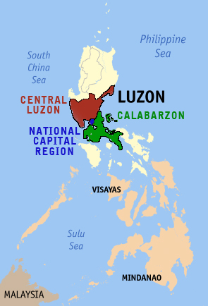
Figure 5. Target Market Regions
      - Positioning Strategy
Aside from positioning Las Casas as a place for field trips and our grandparent’s vacation place, Las Casas Filipinas De Acuzar will also position itself as a significant place to celebrate special moments in the lives of any Filipinos with its showcased history-enriched 19th century buildings and vicinity. Las Casas Filipinas De Acuzar is also a place where staffs execute best customer service to give guests and clients their best well-celebrated historic experience.
Las Casas Filipinas De Acuzar will not only cater to family and group outings but also, to special events such as weddings, debuts and other corporate or social celebrations. Las Casas Filipinas De Acuzar will be a great place to celebrate momentous events like what was previously stated because of the dramatic Filipino setup it gives with its wide parking area, spacious event location, beach, amenities, facilities and its best Filipino foods.
      - Marketing Mix
The marketing mix is composed of the eight P’s of services marketing. Las Casas Filipinas De Acuzar will have a timely changes and improvements on strategies it currently implements for its product, price, place, promotion, people, process, physical environment and productivity and quality.
- Product
Las Casas Filipinas De Acuzar, as a sub-brand of the house of brands of Genesis Hotels and Resorts Corporation, will establish itself with a unique value proposition by a more identifiable and recognizable hotel brand or corporate design that will help them achieve their market and positioning objectives. The logo will be used for marketing purposes only and will not separate Las Casas Filipinas De Acuzar from the group of hotels owned and managed by Genesis Hotels and Resorts Corporation.



Figure 6
Las Casas New Corporate Logo
Church, spa, gym and bridge, church
Advanced technologies are available to foster more effective activities like WiFi connection
- Price
La Casas uses dynamic pricing or pricing differently on individual customers or situations. Although this is the practice used, La Casas also created promo bundles and discounts so that everyone can enjoy their services.
The resort offers day tour and living-out packages as well as accommodations in the villas and different casas available for those who want to stay longer in the place. The rates are as follows:
Table 3
Paseo De Ascolta Current Price Rates
Paseo De Escolta | Off peak  Decreased by 10% | Price for 1 and half  Yrs. Increased 10% | Holidays/ peak  Seasons increased  Of 20%
Studio Deluxe  (Minimum of 2 adults/  2 kids) | PhP 3,442 nett  per night | PhP 4,207 nett  per night | Php 4,590 nett  per night
Studio Deluxe with loft  (Minimum of 2 adults/  2 kids) | Php 4,702 nett  per pnight | Php 5747 nett  per pnight | PhP 6,270 nett  per night
Executive Suite  (Minimum of 4 adults/  2 kids) | Php 6,502 nett  per night | Php 7,947 nett  per night | Php 8,670 nett  per night

Inclusions:
- Set Breakfast at the Marivent Café
- (2 persons in a Studio and 4 persons in Executive Suites)
- Use of Swimming Pool and Beach Area
- Guided Heritage Tour
- All Taxes and Service Charge
Table 4
Heritage Houses Current Price Rates
Heritage Houses | Off peak  Decreased by 10% | Price for 1 and half  Yrs. Increased 10% | Holidays/ peak  Seasons increased  Of 20%
Casa Binondo 1  (4 Bedrooms house good  For 8pax) | PhP 18,018 | PhP 22,022 | PhP 24,024
Casa Binondo 2  (3 Bedrooms house good  For 6 persons) | PhP 13,503 | PhP 16,504 | Php 18,004
Casa Meycauayan  (5 Bedrooms house good  For 10pax | Php 22,532 | Php 27,539 | PhP 30,043

Inclusions:
  - Guided tour of the heritage houses
  - Taxes and Service Charges

Table 5
Day Tour Current Price Rates
DAY TOUR RATES | Off peak  Decreased by 10% | Price for 1 and half  Yrs. Increased 10% | Holidays/ peak  Seasons increased  Of 20%
PACKAGE 1  (set lunch) | Php 900 nett  per person | Php 1,100 net  per person | Php 1,200 net  per person
PACKAGE 2  (buffet lunch) | PhP 1,080 nett  per person | PhP 1,320 net  per person | Php 1,440 nett  per person

Inclusions:
- Welcome Drinks
- 30 Minutes to 1 Hour Guided Tour of the Heritage Houses
- Entrance Fee and Use of Beach Area
- 1 Lunch, Afternoon Snack, 2 Tetra-packed Juices, 2 Bottles of Mineral Water
- Vicinity Map
- All Taxes and Service Charge
Optional: Buffet Ihaw-ihaw / Barbeque, add PhP500 nett per person (on top of the buffet package only). Guaranteed minimum required is 10 persons for set meals and 50 persons for buffet meals.
- Place and Time
Las Casas will be partnering with bus companies to make the travel easier for commuters. Also, a pick up bus from a certain Landmark in Bataan will be implemented for the commuters.
Road development for the route to Las Casas, Bagac, Bataan will be done through the help of the Local Tourism Department.
- Promotion and Education
The corporate logo will be seen in all advertising collaterals, website, and supplementary products such as pillows, towels and toilet kit that are seen inside the hotel and resort’s vicinity.
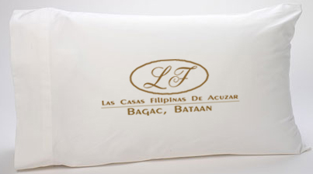



Figure 7
Room Amenities with Corporate Design
The company will use different marketing promotions to invite visitors and to create revisits. Company logo will be seen in all advertising collaterals, website, and products such as pillows, towels and toilet kit that are seen inside the hotel and resort’s vicinity. Listed below are the different promotions
  - Free spa service
  - Accommodation discounts up to 30% for a three say stay
  - Discounts on use of amenities
A membership will also be offered to guest that entitles them for privileges such as:
- Service shuttle
- Unlimited use of chosen facilities
- Free breakfast buffet meal
- Priority reservation
The website will also be reconstructed and different transactions will be available. The annual cost for domain registration is P10, 000 and P50, 000 for redecoration. Services that will be available online are:
- Online reservation payment
- Room images that shows availability, cost an room features
- Customer service will be available through chat
Print ads will also be created to create awareness; print advertisements will be posted in fashion and lifestyle magazines in the country. Costing will be as follows:
Table 6
Magazine Ad Cost
Lifestyle and fashion magazine | Size | Cost
Weddings  With45,000 claimed circulation  With bi-monthly issue | Full bleed size  8.5”x11” | OBC | PHP80,000
 | Full bleed size  8.5”x11” | IFC | PHP75,000
 | Full bleed size  8.5”x11” | IBC | PHP70,800
 | Full bleed size  8.5”x11” | IP4C | PHP44,000

T
F
For the tarpaulins, an 088.mm thick PVC coated tarpaulin will be used to create awareness. The tarpaulin that will be used will measure 4’x12’ meters with a thickness that will ensure its durability. It will be posted in nearby towns and roads leading to the hotel. The tarpaulins will be the guest’s guide so it will contain road directions and distance from the hotel.
Billboards will also be posted along North Express way, south Luzon Express way, SCTEX and Edsa. This is to reach millions of travelers and commuters that are the hotels potential guest. The size of the billboard will be 20 x 80 feet in height and width that cost Php 40,000 in printing. Billboards will be located in NLEX, SLEX and SCTEX. Prices of billboard rentals are:
Table 7
Billboard Cost
Location | Price
NLEX | 150,000
SCTEX | 150,000
SLEX | 100,000

Billboards will be up for 3 months which are March 2011, May 2011 and December 2011.
- Process
Improvements in the service process will be seen in the standards and scripts observed by the service providers or employees. Details of the improvement will be as follows:
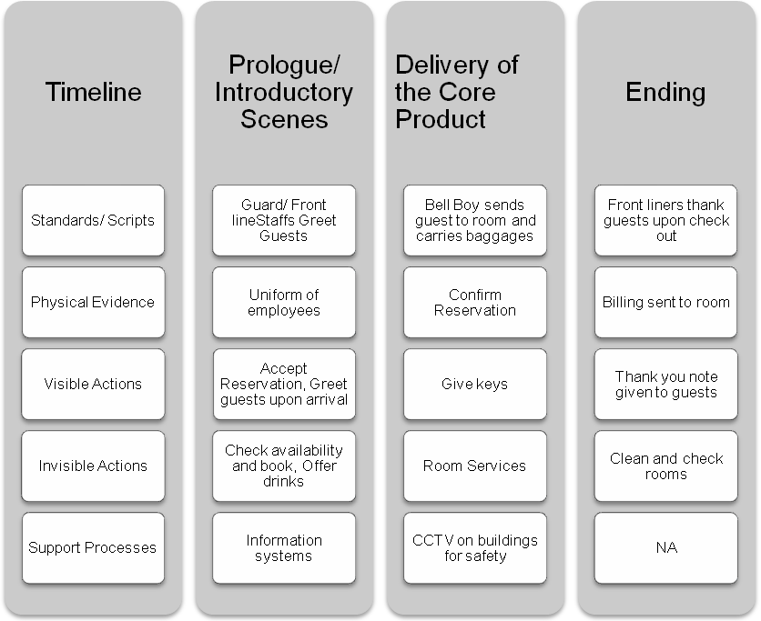
Figure 8
New Process
- Physical Environment
The Parking lot is the very first spot where Tourist will pay attention initially upon arrival to the Resort. From the first spot Tourists basically expresses already first impressions whether it is convenient, comfortable and enticing, or the other way-inconvenient, uncomfortable, not enticing at all. These first impressions can create thoughts affecting the whole place of the Resort. That’s why every places especially in a Hotel or Resort where wide guests are being accepted, in the Parking Lot where the first seen place must pay consideration.
Good impressions from guests as initially said a goal as each guests satisfactions counts. Tourists will not only keep coming back to the place but also they are key as an advertising support -through spread of mouth/words. The allotted parking space of Las Casas Filipinas De Acuzar Resort needs a renovation to entice guests as they arrive to the place. As they were enticed, they are feeling welcome and eager more to explore the entire place. The parking space will be planted with trees and grass to make the area cleaner and greener.
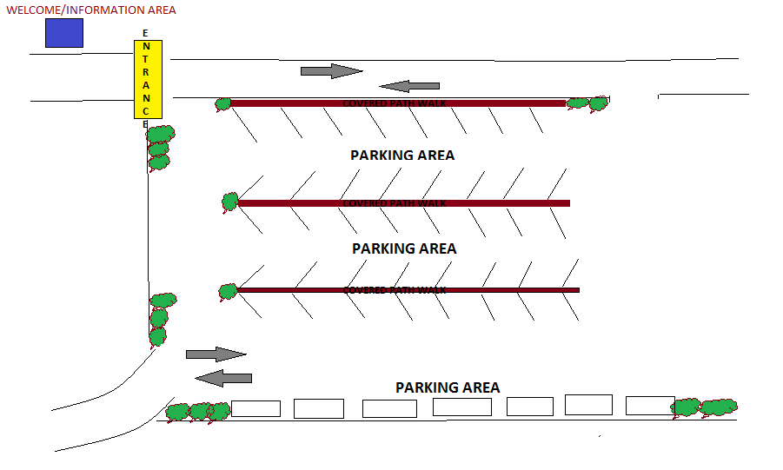
Figure 8
Parking Space
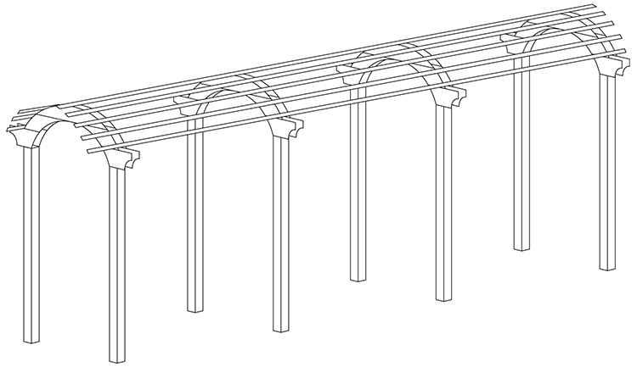
Figure 9
Covered Path walk
The path walk is build with old wood wreckages from old houses with vine plants, this will help protect guests from the heat of the sun and get soaked from the rain. The path walk and the vine plants will also serve an additional beauty to the place, heading to the entrance of Las Casas Filipinas De Acuzar.
At the Information area where receptionist welcomes with smiles on their faces, a sofa and an LCD TV where historical information’s are previewed will be included in the guest lounge design.
The Information Area has the major role in one Hotel or Resort. As acceptance where queries of the guests is being entertained, they carry all the in and outs needs of the guests; basically all the information needed is here to arrange with the receptionist like the reservations, schedules, room rates, etc. An LCD TV is needed where historical information about the place is being previewed, like who has founded and developed the place, what’s exciting in the place that makes it unique from the rest of the resorts around, and so on. These information’s may somehow answers tourists to count questions about the place and as we all know that technology now a days is being impart already everywhere, thus added attraction to the place.
- People
An Events Manager will be hired for wedding, debuts and other celebrations. Caterers and photo/ video coverage will be outsourced for the event. Various catering and photo/ video companies will be accredited for events.
- Productivity and Quality
- Increase in security level and manpower
- Allocating different tasks to each housekeepers
- Improvement of facilities
- Outsourcing if possible
- Backstage performance
- Discipline of staff towards the customers
      - Marketing Research
Surveys will be given within the stay of guests together with a complementary kit to ensure the answering of the surveys.

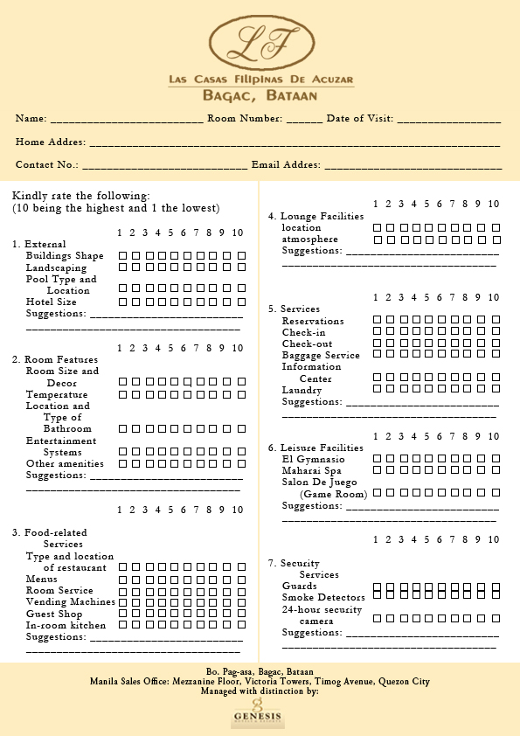
Figure 10
Survey
- Recommendations
      - Partnership with local government units for tourism support.
      - Partnership with land and sea travel companies for an easier means of transportation to Las Casas for commuters.
      - Development of route to Las Casas
      - Mini sea port for easy access through sea.

